Contracts Summary
USER GUIDE
Navigate
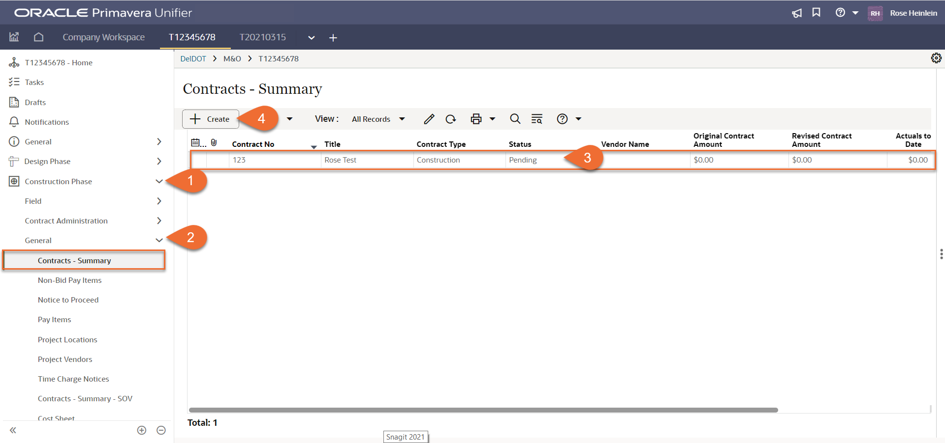
- In a Unifier project, expand Construction Phase folder on the navigation pane to the left
- Click General – Contracts- Summary to go to Contracts Summary module
- Contract Summary Records will be auto created by the Project Letting Business Process, upon completion of the workflow. Auto-created records will appear as line items and can be opened, edited and sent for Review.
- If another contract is needed for a project, a record can be created by Clicking + Create

Create
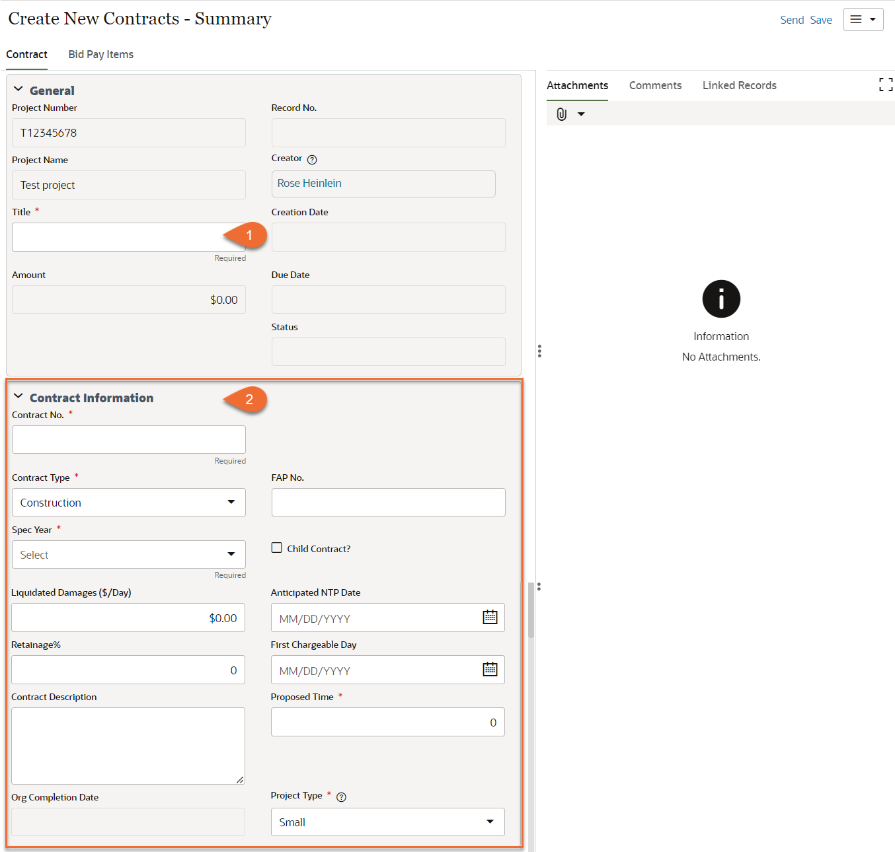

- Title: Add the title of the contract
- Contract Information: Complete the following fields:
  - Contract Number: Add the contract number
  - Contract Type: Select from the dropdown (Unit Price, Lump Sum, T&M, GMP, Advanced Utilities, Design, CEI, Construction, Other)
  - FAP No.: Add the FAP number, if applicable
  - Spec Year: Select from the dropdown (2001, 2016, CSI, 2020)
  - Child Contract?: Select the box if this is a child project
  - Liquidated Damages ($/Day): Add the amount, if known
  - Anticipated NTP Date: Select the Anticipated NTP date
  - Retainage%: Add the retainage %, if known
  - First Chargeable Day: Select the First Chargeable Day
  - Contract Description: Provide a contracts description, if necessary
  - Proposed Time: Enter the projected number of days
  - Project Type: Select the project type

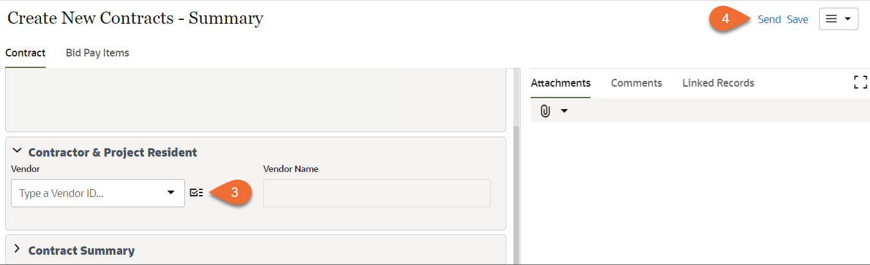
- Vendor: Select the Vendor, if known. The vendor must be added to the Project Vendors BP before it can be selected here.
- Submit: Click Submit
Review

